

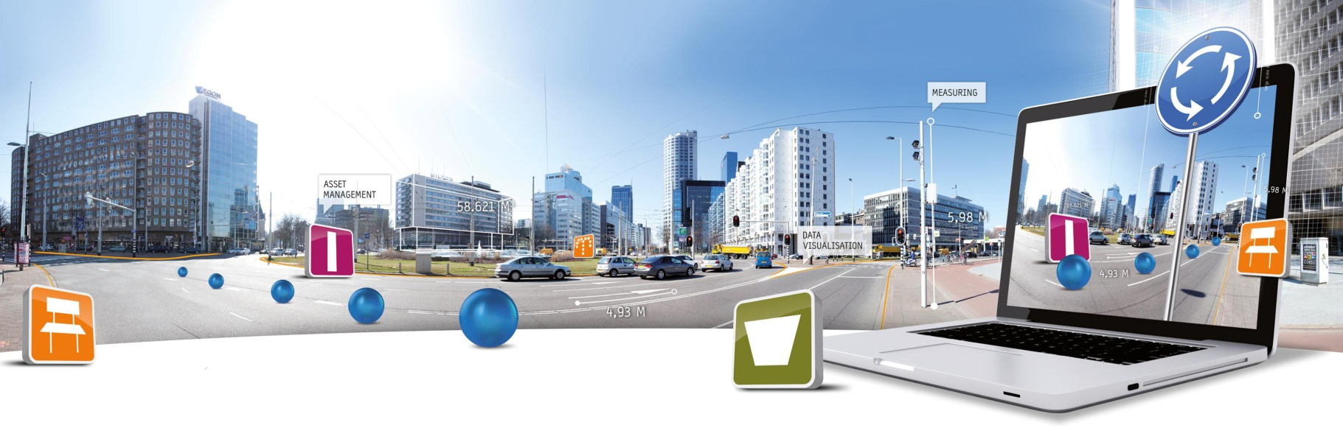

**GlobeSpotter for ArcGIS Desktop Installation Manual**

Datum: 17 juli 2014

CycloMedia Technology B.V. | **T** +31 (418) 556100 | **E**: [info@cyclomedia.com](mailto:info@cyclomedia.com)

# 1. Installation

To install GlobeSpotter for ArcGIS Desktop you must perform the following steps:

1. Check if ‘Adobe Flash Player’ is installed on your machine. If ‘Adobe Flash Player’ is not, installed, install ‘Adobe Flash Player’.
2. There are two ways how ‘GlobeSpotter for ArcGIS Desktop’ can be loaded into ArcMap:
   1. ‘GlobeSpotter for ArcGIS Desktop’ can be used from a location on disk or network (go to paragraph 3).
   2. ‘GlobeSpotter for ArcGIS Desktop’ can be installed in ArcMap (go to paragraph 4).
3. The use of GlobeSpotter for ArcGIS Desktop by a location on disk or network is the easiest method for distribution GlobeSpotter for ArcGIS Desktop across multiple computers.
   1. Copy the ‘GlobeSpotter for ArcGIS Desktop’ Add-in file to a disk or network location.
   2. Start ArcMap.
   3. 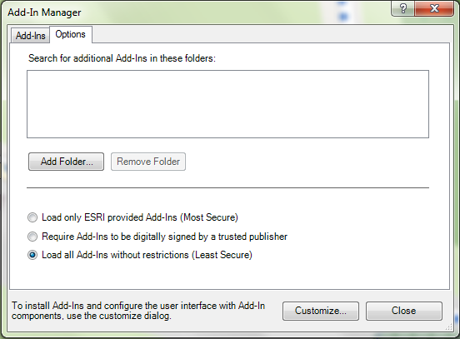Select menu: Customize-> Add-In Manager.
   4. Select the Options tab. (Figure 1) .

Figure 1: Add-In manager, Options tab

* 1. 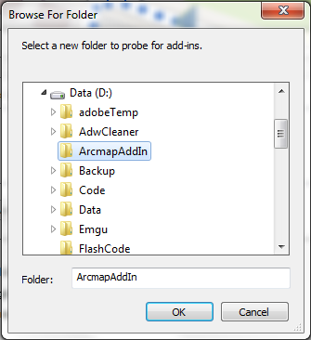Click on the button: <Add Folder...>

Figure 2:Browse to the folder where ‘GlobeSpotter for ArcGIS Desktop’ is located

* 1. Browse to the folder were ‘GlobeSpotter for ArcGIS Desktop’ is located (Figure 2).
  2. Click on the button: <OK>
  3. Close the Add-In manager and close ArcMap.
  4. Start ArcMap.
  5. Select menu: Customize-> Add-In Manager.
  6. Check whether GlobeSpotter for ArcGIS Desktop is trusted. (Figure 3)
  7. 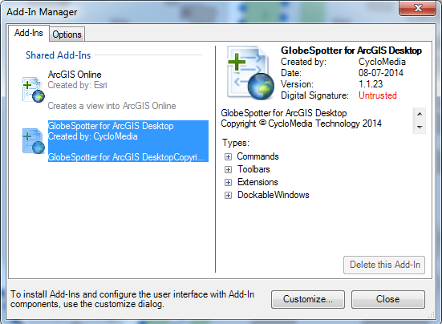If the ‘GlobeSpotter for ArcGIS Desktop’ Add-In is not trusted, close the Add-In Manager, close ArcMap and install the attached certificate (thawte-intermediate-ca.cer).

Figure 3: Add-In Manager, Add-Ins tab, check GlobeSpotter for ArcGIS Desktop is trusted

* 1. To install the certificate, you must perform these steps:
     1. 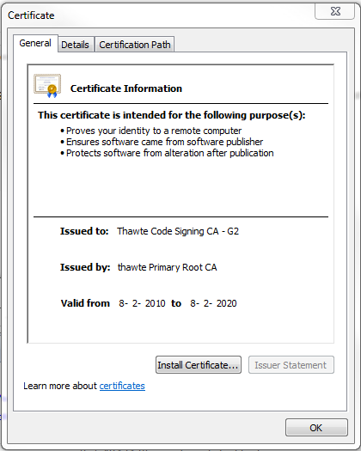Install the thawte-intermediate-ca.cer by double-click the certificate (Figure 4).
     2. Click on <Install Certificate...> and the installation wizard for the certificate is started (Figure 5).

Figure 4: Install the Thawte-intermediate-ca

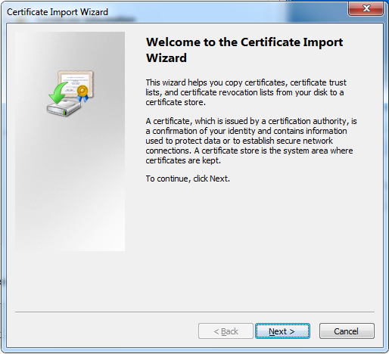

Figure 5: Certificate import wizard

* + 1. 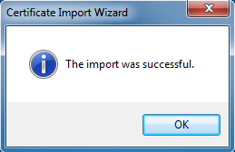Click: <Next>, <Next>, <Finished> and the certificate is installed ().
  1. Start ArcMap.

Figure 6: The import was successful

* 1. Select menu: Customize -> Add-In manager
  2. 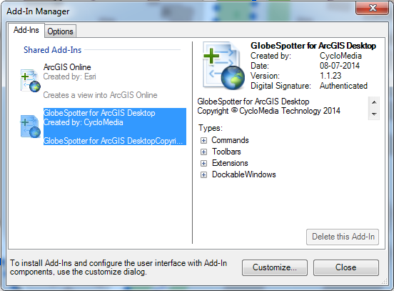Make sure ‘GlobeSpotter for ArcGIS Desktop’ is now trusted ().
  3. You may proceed to paragraph .

1. To install ‘GlobeSpotter for ArcGIS Desktop’ in ArcMap you must follow these steps:

Figure 7: Add-In Manager, Add-Ins tab, Check GlobeSpotter for ArcGIS Desktop is Authenticated.

* 1. If you have installed a previous version of ‘GlobeSpotter for ArcGIS Desktop’, first delete the previous version:
     1. Start ArcMap.
     2. Customize -> Add-In Manager (Figure 9)
     3. Select the ‘GlobeSpotter for ArcGIS Desktop’ Add-In and click on the button: <Delete this Add-In>.
     4. Close the Add-In Manager and close ArcMap.
  2. 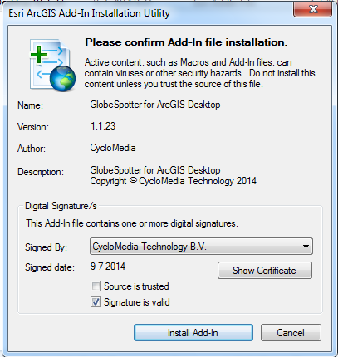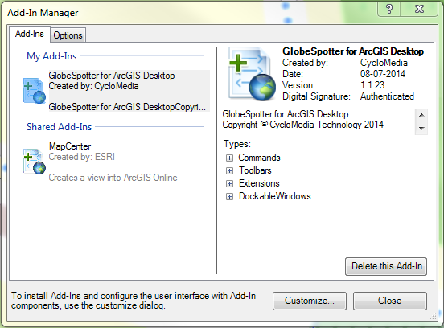Double-click the ‘GlobeSpotter for ArcGIS’ Desktop Add-In and check whether the Add-In is trusted.

Figure 8: GlobeSpotter for ArcGIS Desktop Add-In installation (not trusted)

Figure 9: Add-In Manager, Add-Ins tab, Delete previous version of ‘GlobeSpotter for ArcGIS Desktop’

* 1. If the ‘GlobeSpotter for ArcGIS Desktop’ Add-In is not trusted, Click <Cancel> and install the attached certificate. (thawte-intermediate-ca.cer).
  2. To install this certificate, check step: XIII from paragraph 3).
  3. 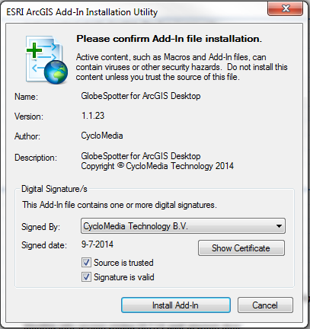Double-click the ‘GlobeSpotter for ArcGIS Desktop’ Add-In again and check whether the Add-In is now trusted. (Figure 10)
  4. Select <Install Add-In> to install the Add-In.

Figure 10: ‘GlobeSpotter for ArcGIS Desktop’ Add-In installation (trusted)

* 1. Start ArcMap.

1. If you start ArcMap for the first time after installing the ‘GlobeSpotter for ArcGIS Desktop’ Add-In, you get the agreement form (Figure 12).
2. 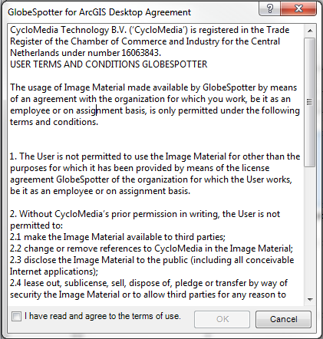Checkmark: ‘I have read and agree to the terms of use’ and click on ‘OK’.

Figure 12: Agreement form

1. 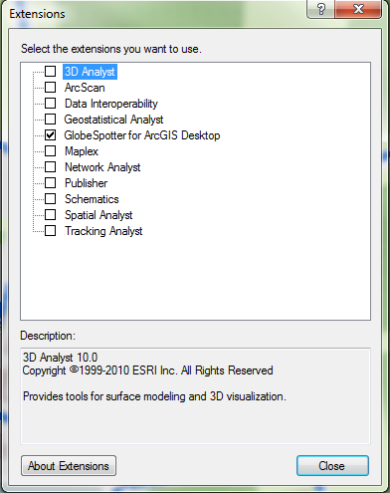If you do not get the agreement form, select the menu: Customize -> Extensions. (Figure 11).
2. Checkmark: ’GlobeSpotter for ArcGIS Desktop’ extension and you will now get the ‘GlobeSpotter for ArcGIS Desktop’ Agreement. You get the agreement only once.

Figure 11: Extensions menu, select the extension ‘GlobeSpotter for ArcGIS Desktop’

1. Close the extensions form.
2. Select the GlobeSpotter toolbar: Customize -> toolbars -> GlobeSpotter (Figure 14).
3. Select the ‘GlobeSpotter for ArcGIS Desktop’ icon (Figure 13) of the Cyclorama toolbar. You get the ‘GlobeSpotter for ArcGIS Desktop’ form now.

Figure 13: The selected 'GlobeSpotter for ArcGIS Desktop' icon

Figure 14: GlobeSpotter toolbar

1. 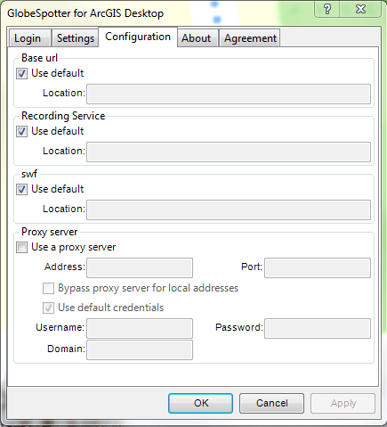Select the configuration tab (Figure 15)
2. If you use a proxy server, you can checkmark: ‘use a proxy server’ and enter the data about your proxy server.

Figure 15: ‘GlobeSpotter for ArcGIS Desktop’ form, Configuration tab

1. If you are using a local installation, uncheck the base url and the swf url and fill in the correct urls.
2. Select the Login tab (Figure 16).
3. Enter your username and password and press: <Apply>
4. If you see ‘Login Successfully’, you are logged in.
5. 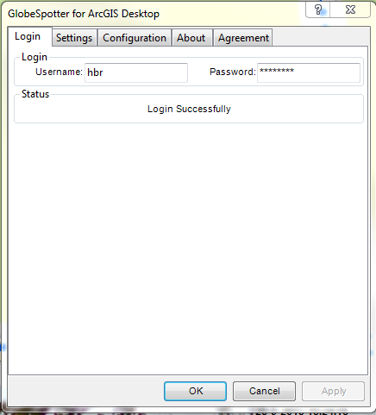Now you are ready for use the ‘GlobeSpotter for ArcGIS Desktop’ Add-In.

Figure 16:’GlobeSpotter for ArcGIS Desktop’ form, Login tab